**Web Base Project**

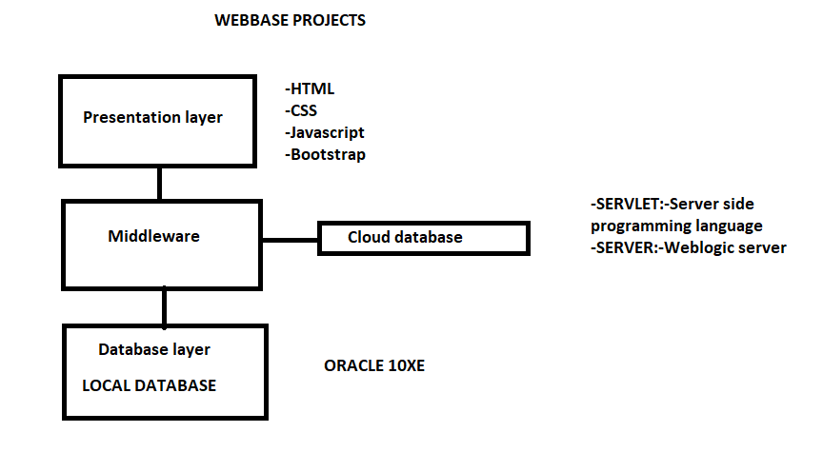

**Presentation layer**:-The presentation layer resides at Layer 6 of the Open Systems Interconnection ([OSI](https://www.techtarget.com/searchnetworking/definition/OSI)) communications model and ensures that communications that pass through it are in the appropriate form for the recipient application.

Middleware layer:-  middleware is an abstraction layer that acts as an intermediary.

Database layer:- The Database layer consists of technologies that give your Web and mobile applications the ability to store and retrieve data.

HTML Program:-

<html>

<body bgcolor=yellow>

<h1><center>Welcome To Web Project</center></h1><hr>

<form action=second>

<table><center>

<tr><td>Enter your name<td><input type=text name=t1 size=20 required></tr>

<tr><td>Enter your password<td><input type=password name=t2 size=20 required></tr>

<tr><td>Enter your DOB<td><input type=date name=t3 size=20 required></tr>

<tr><td>Enter time<td><input type=time name=t4 size=20 required></tr>

<tr><td>Enter your email<td><input type=email name=t5 size=20 required></tr>

<tr><td>Enter your age<td><input type=number name=t6 size=20 required></tr>

<tr><td>Enter your Gender<td><input type=radio name=t7 value=male>Male<input type=radio name=t7 value=female>Female</tr>

<tr><td>Lifestyle<td><input type=checkbox name=t8 value=Food>Food<input type=checkbox name=t8 value=Clothing>Clothing<input type=checkbox name=t9 value=Riding>Riding<input type=checkbox name=t10 value=Games>Games<input type=checkbox name=t8 value=Goal>Goal</tr>

<tr><td>Enter your Nationality<td><Select name=t11>

<option>Indian</option>

<option>American</option>

<option>Japanese</option>

<input type="Reset" value="Reset"/>

</select>

</tr>

<tr><td><td><input type=submit value=submit></tr>

</center>

</table>

</form>

</body>

</html>

**Tags Definition:-**

<tr>: The Table Row element. The <tr> HTML element defines a row of cells in a table.

<td> :the <td> tag defines a standard data cell in an HTML table.

required:- indicates that the user must specify a value for the input before the owning form can be submitted.

The <hr> element is most often displayed as a horizontal rule that is used to separate content (or define a change) in an HTML page.

* **How to add google map to html coding**
* using <iframe>link</iframe>
* step1:-Go to google map

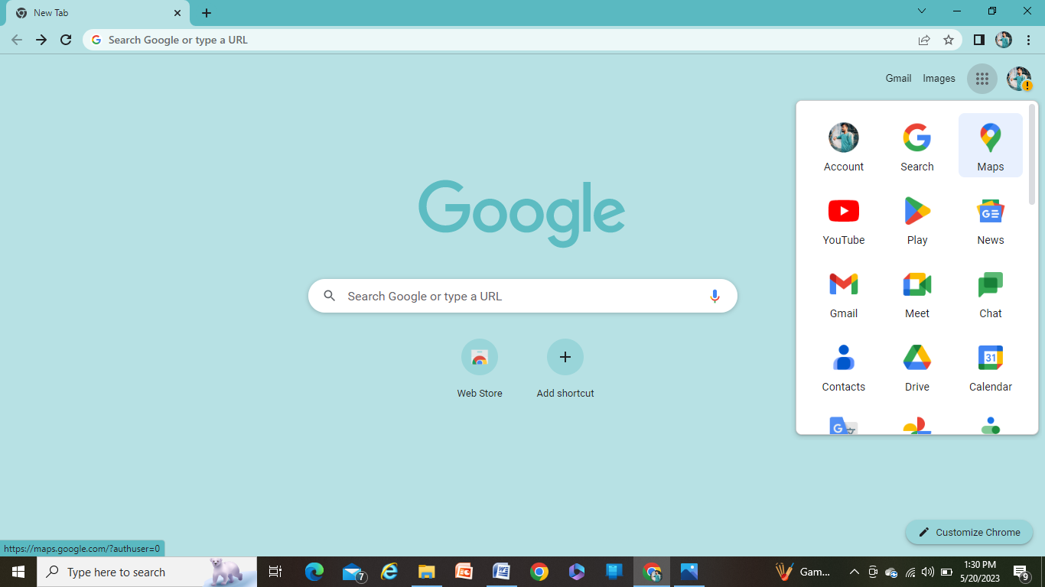

* step2:-Enter the location in the google map

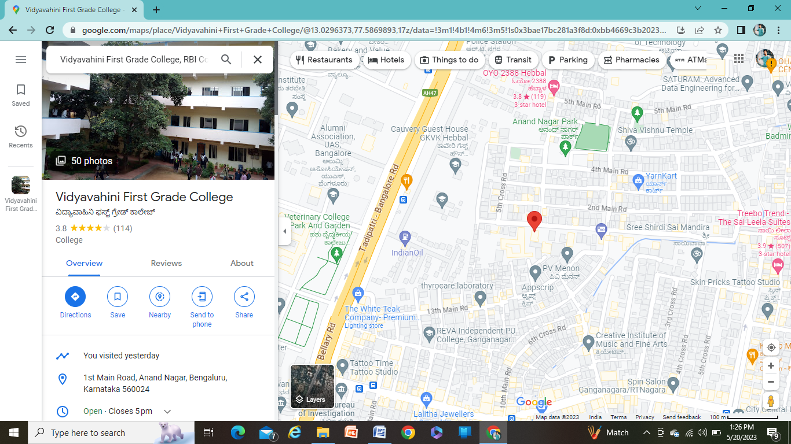

* step3:-After searching the location, click on share



* step4:-click on Embed on map

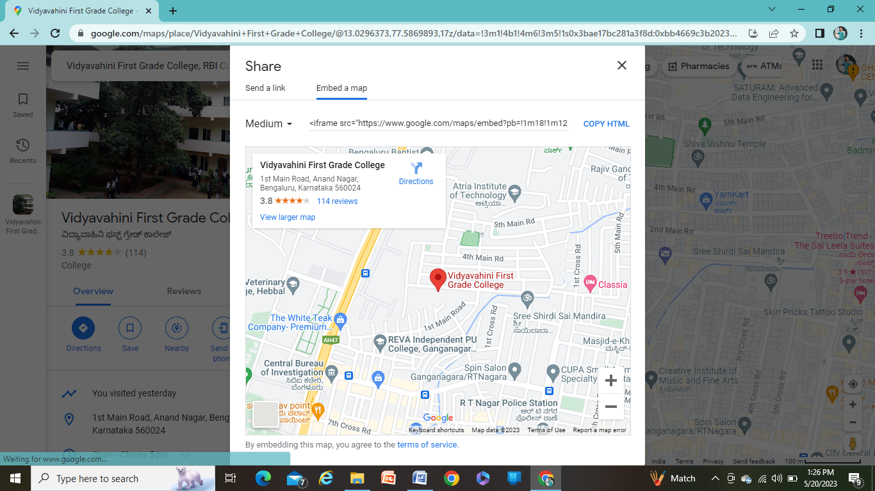

* step5:-click on copy HTML link



* **Enter the codings for the map**

<html>

<body bgcolor="yellow">

<center><h1>Location to Vidyavahini college</h1>

<iframe\src="https://www.google.com/maps/embed?pb=!1m18!1m12!1m3!1d3887.094759384059!2d77.58698927392483!3d13.029637313605496!2m3!1f0!2f0!3f0!3m2!1i1024!2i768!4f13.1!3m3!1m2!1s0x3bae17bc281a3f8d%3A0xbb4669c3b202322f!2sVidyavahini%20First%20Grade%20College!5e0!3m2!1sen!2sin!4v1684469831146!5m2!1sen!2sin" width="1350" height="550" style="border:0;" allowfullscreen="" loading="lazy" referrerpolicy="no-referrer-when-downgrade"></iframe>

</center>

</body>

</html>

* **Output will display as follows:-**

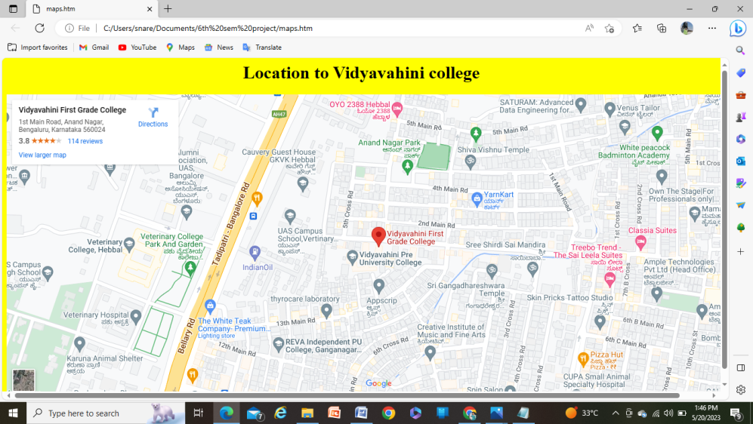

* **Give the codings of map afther the submit button and Link this maps into html page then the output will displays as**

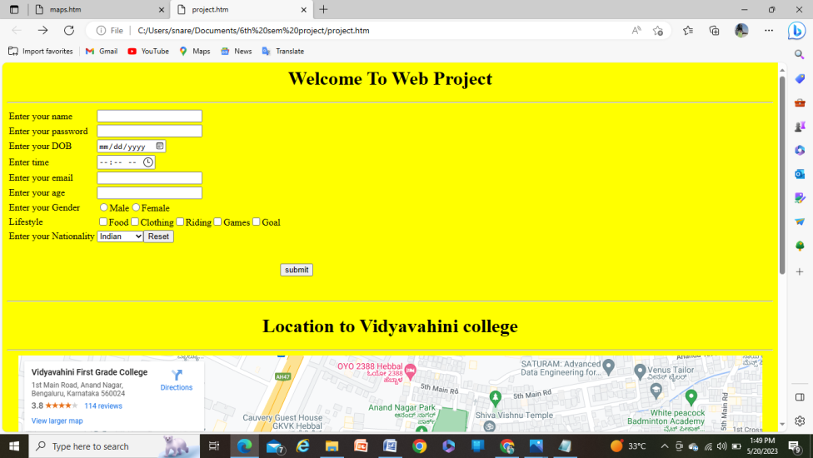

* **Creating a google form**
* How to create Google forms
* Step1:-Go to Google

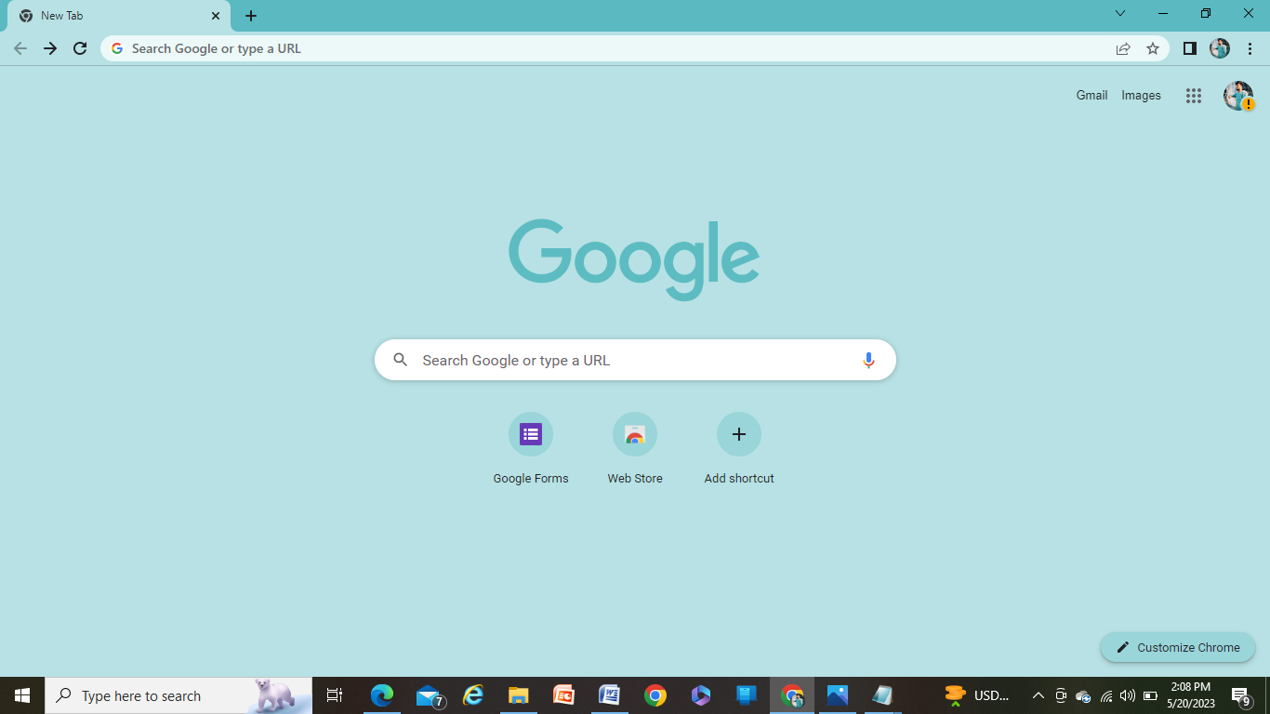

* Step2:-Search <https://google.com/forms>

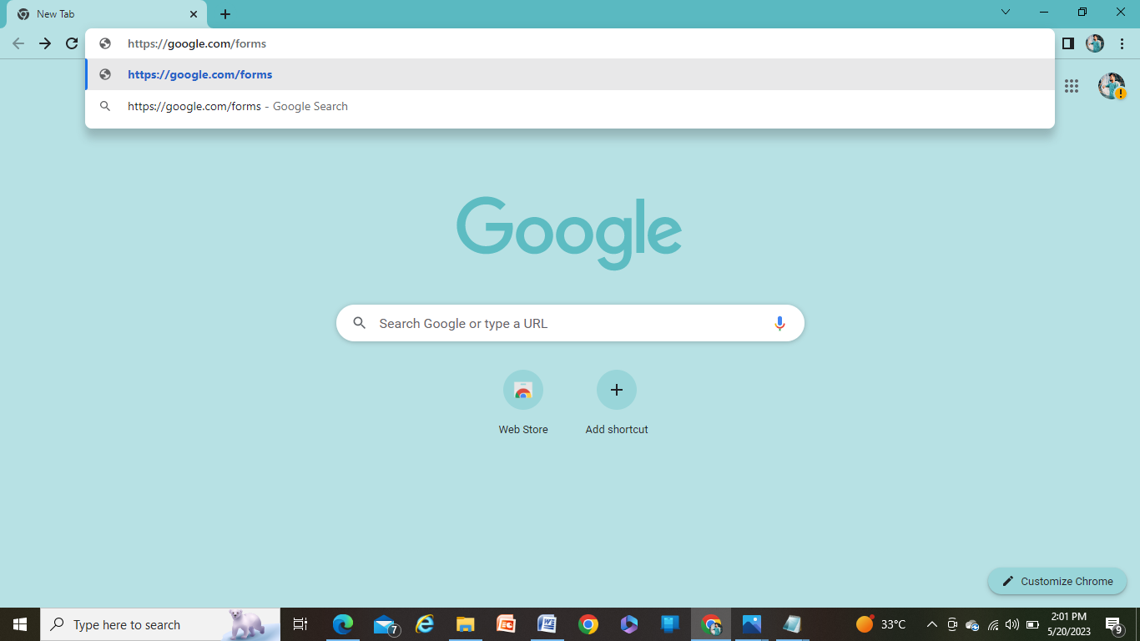

* Step3:-Clink on Blank form

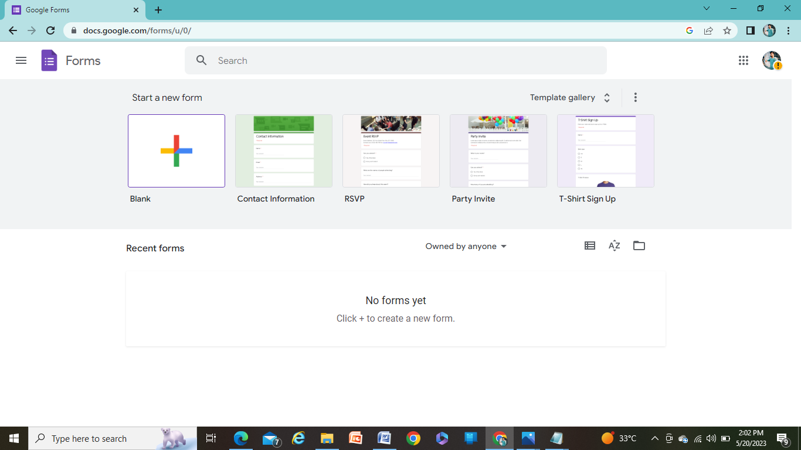

* Step4:-Give the form name as required

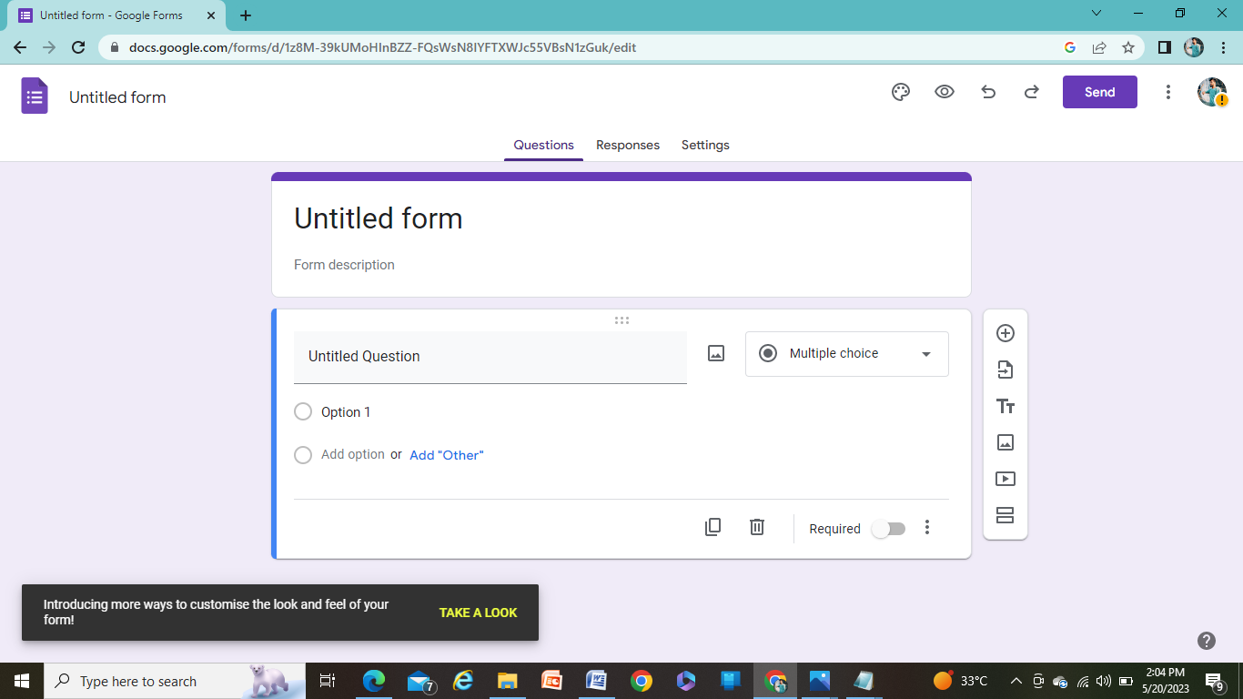

* Step5:-To add a new Question click on +

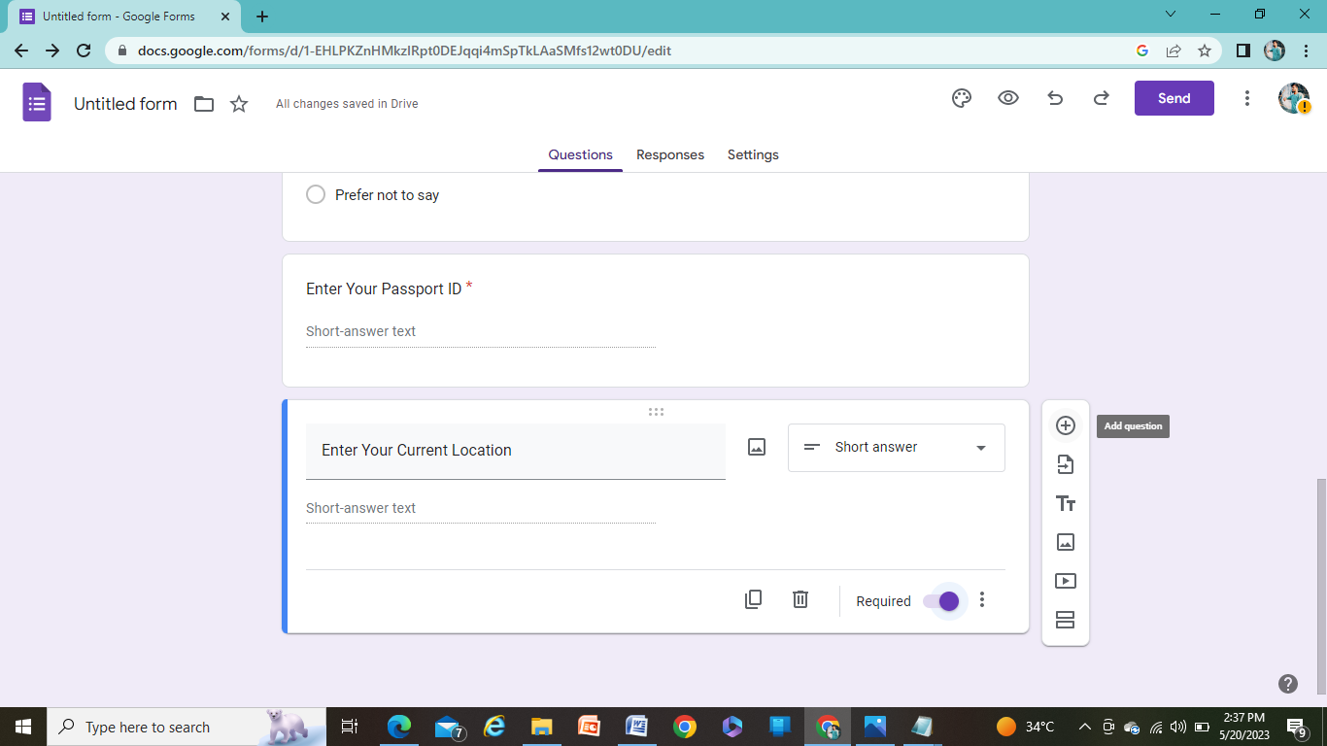

* Step6:-After creating the form name give the fields that are required according to the form which been created

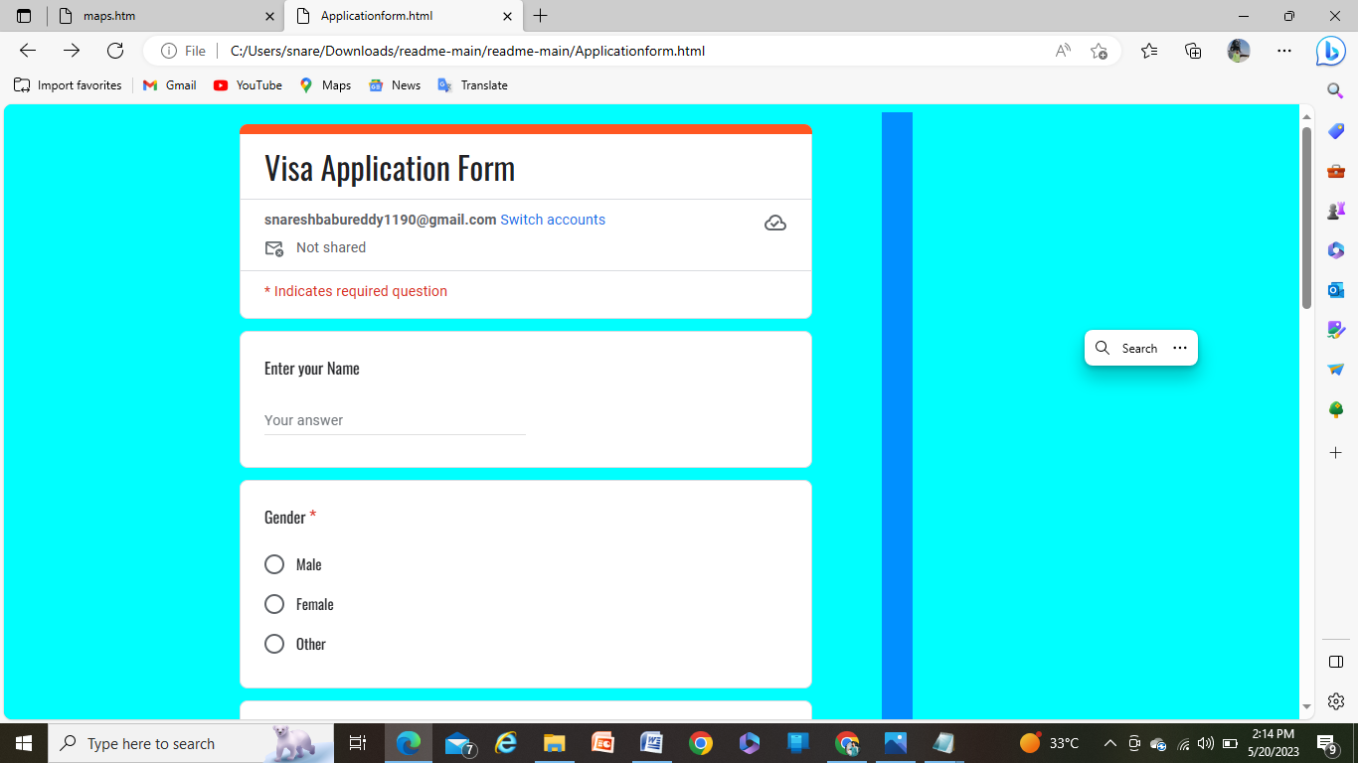

* Step7:-After Giving all the requirements click on submit button

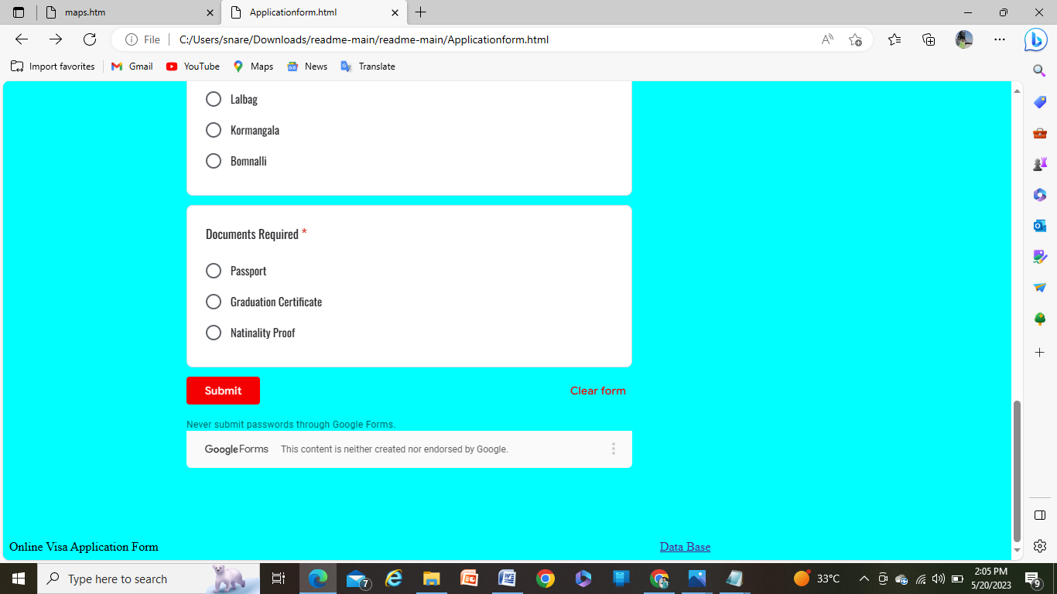

* Step8:-If need the required fields to be mandatory ,turn on the required field

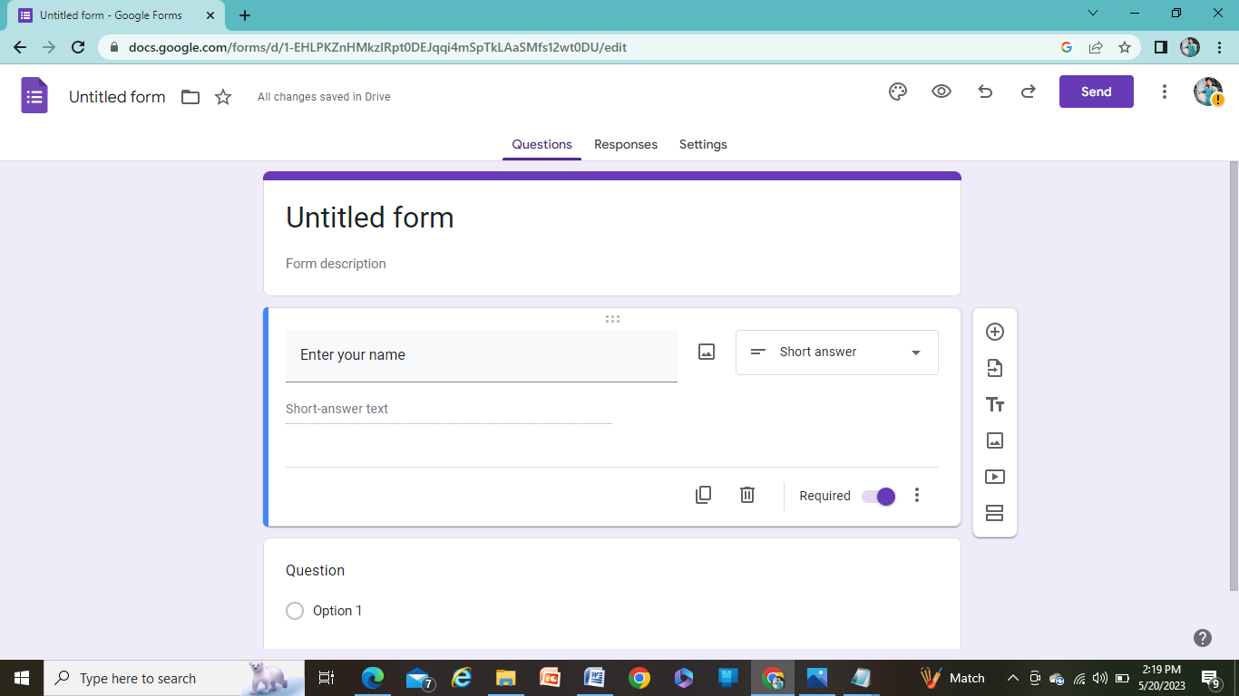

-it displays red* as follows:-

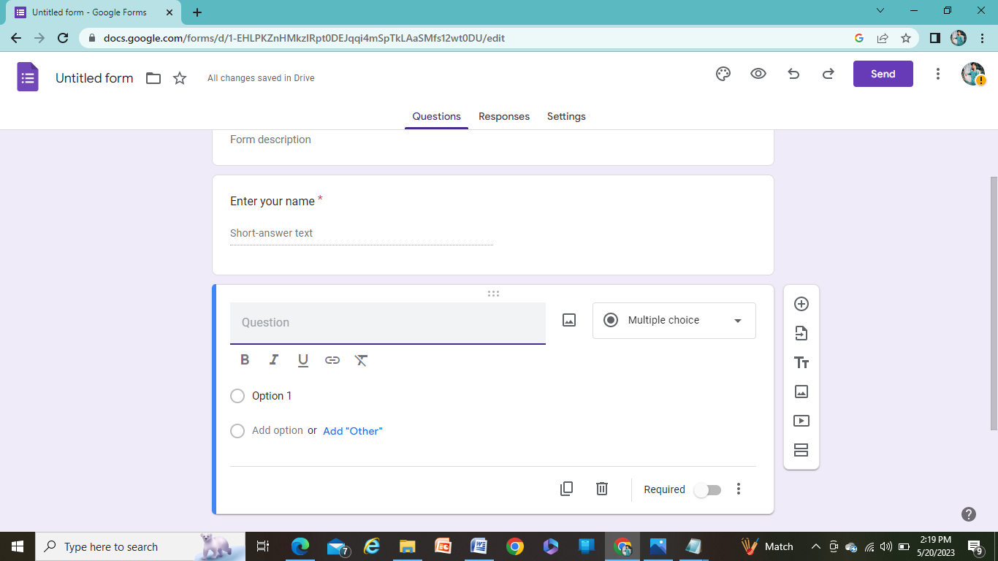

* Step9:-After creating the form, click on Response

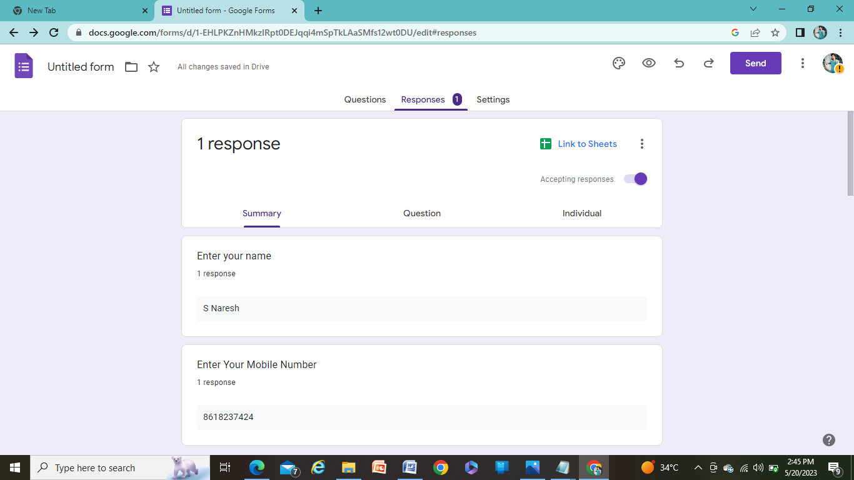

* Step10:-Click on Link to sheets

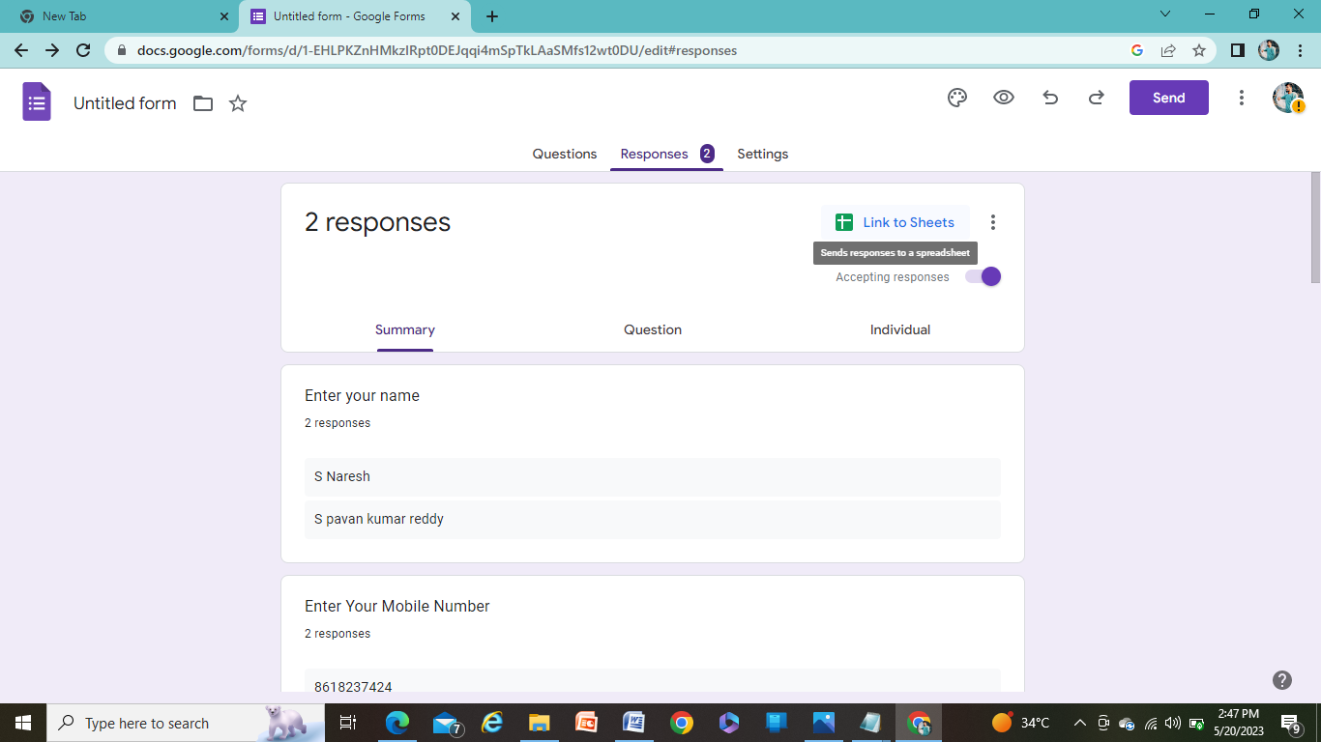

* Step11:-Select on Create a new spreadsheet

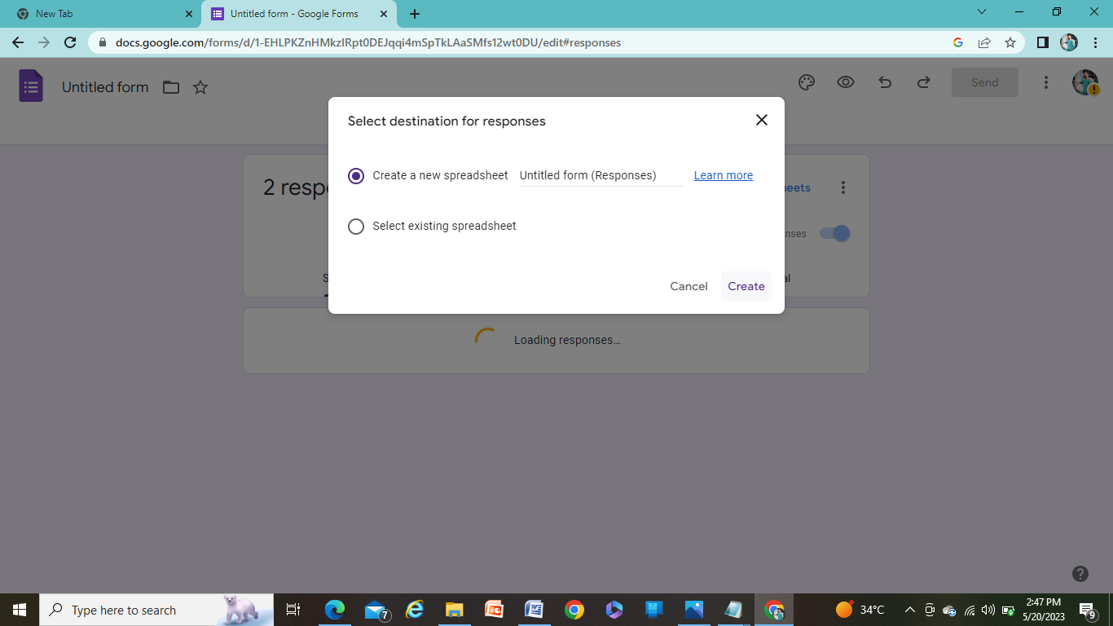

* Step12:-click on Create



* Step13:-Excel sheet will be created as follows with the data given in the above form

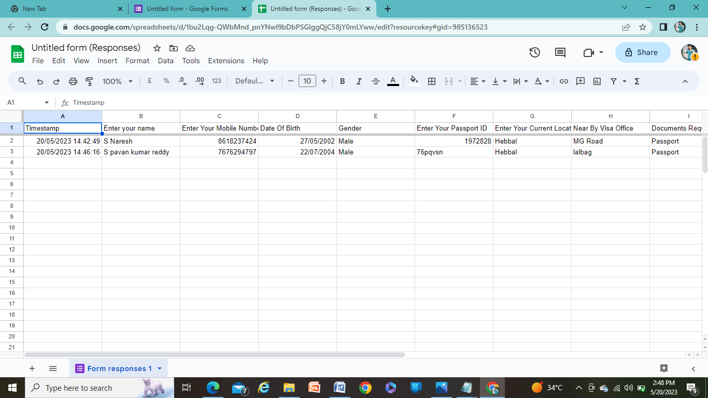

* Step14:-Now you can send created form to Your friends using send button via mail



* Step15:-Enter the mail and click on send

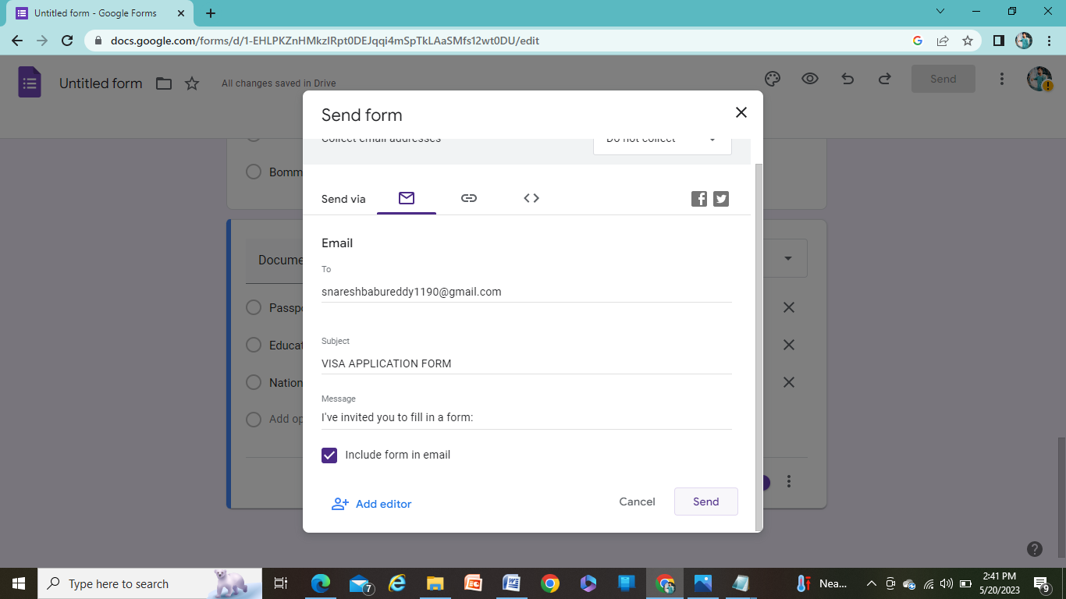

* Step16:-Click on <>

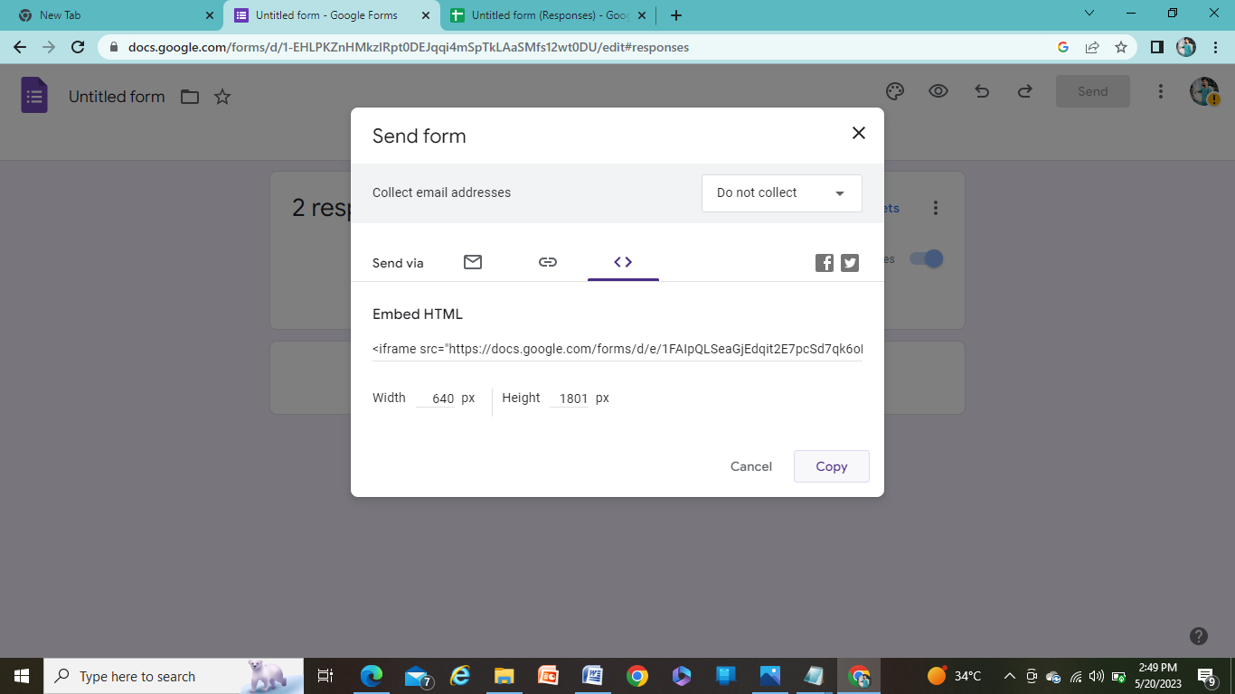

* Step17:-copy the link

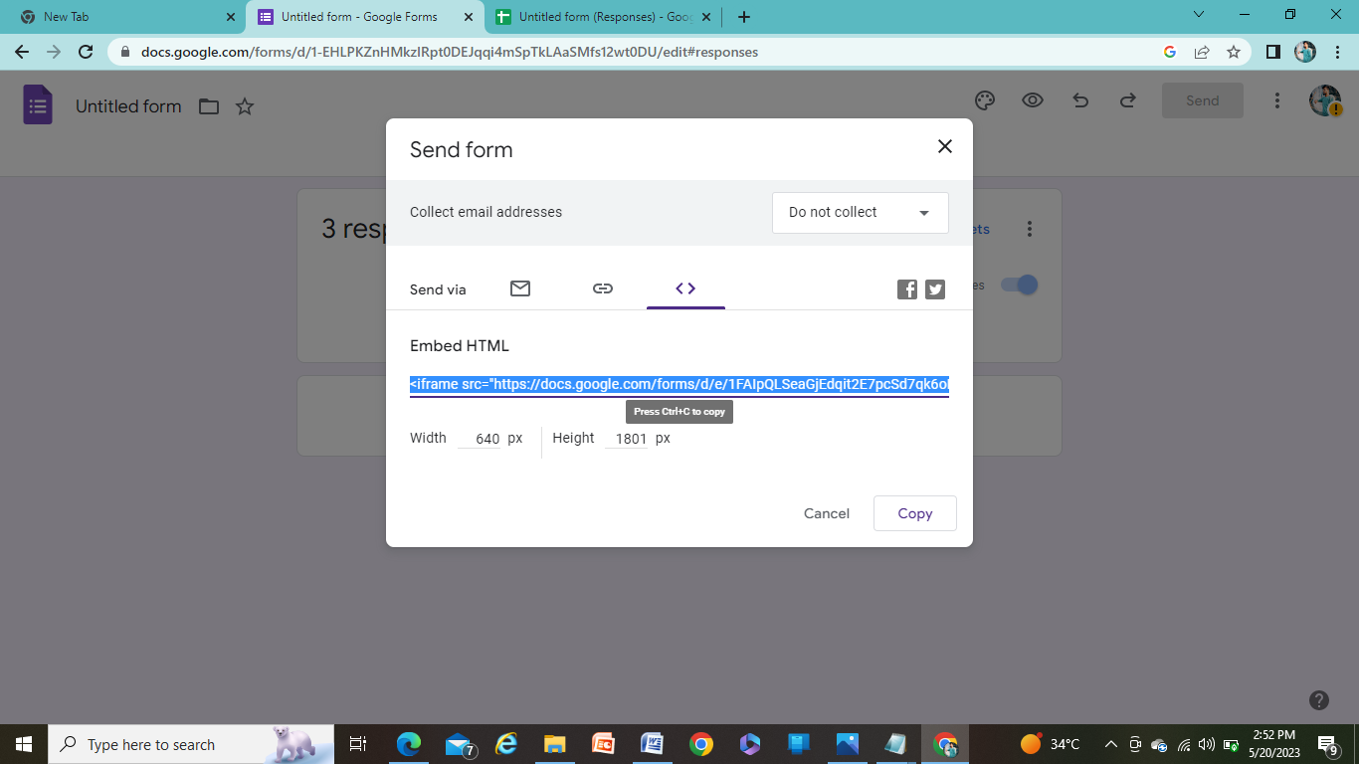

* Step17:-Paste the link in HTML program (page)

<iframe src="https://docs.google.com/forms/d/e/1FAIpQLSeaGjEdqit2E7pcSd7qk6oNUqcIZA9DhWTnT0CdY2PFnZG0-g/viewform?embedded=true" width="640" height="1801" frameborder="0" marginheight="0" marginwidth="0">Loading…</iframe>

* **Copy the Spreadsheet link and paste it in the HTML program**

<a href="https://docs.google.com/spreadsheets/d/1bu2Lqg-QWbMnd_pnYNwl9bDbPSGlggQjC58jY0mLYww/edit?resourcekey#gid=985136523"></a>

* **To display the spreadsheet output, give the button as Next in between the spreadsheet link as**

<a href="https://docs.google.com/spreadsheets/d/1bu2Lqg-QWbMnd_pnYNwl9bDbPSGlggQjC58jY0mLYww/edit?resourcekey#gid=985136523">**NEXT**</a>

* The Button Displays like this

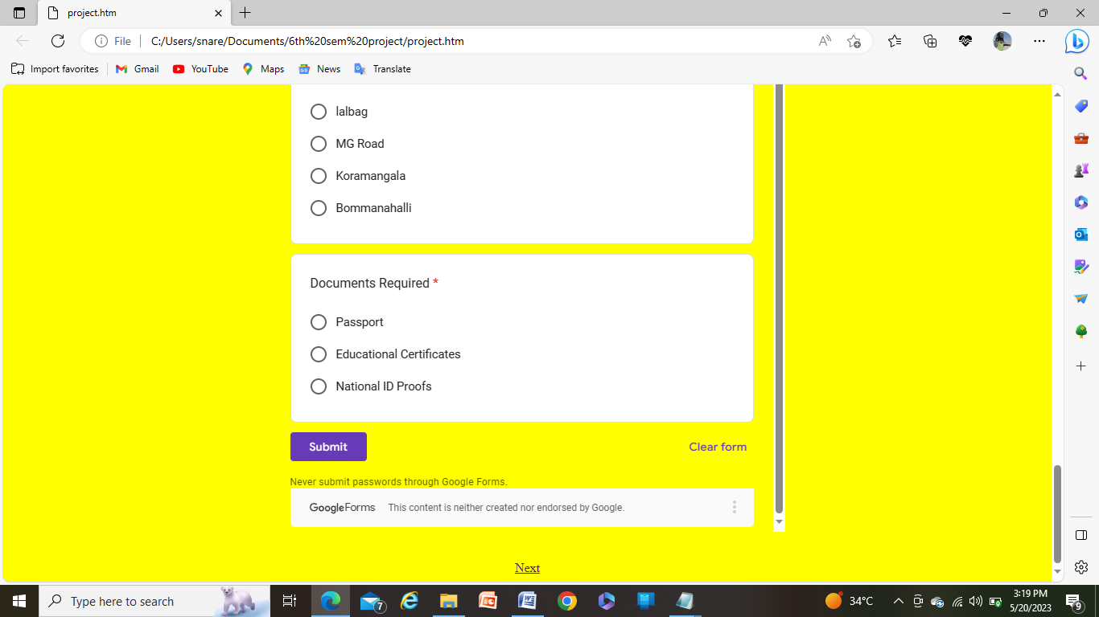

* Click on the **Next** Button to display the data of spreadsheet provided in the application form

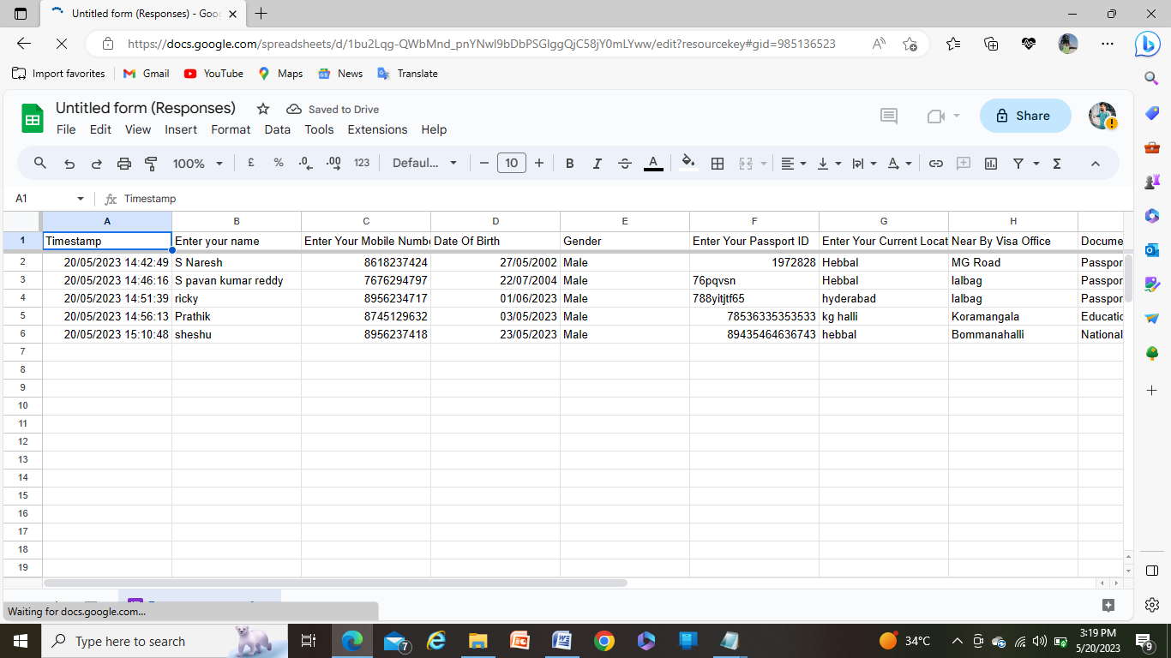

* **HOW TO CREATE A GITHUB ACCOUNT**
* 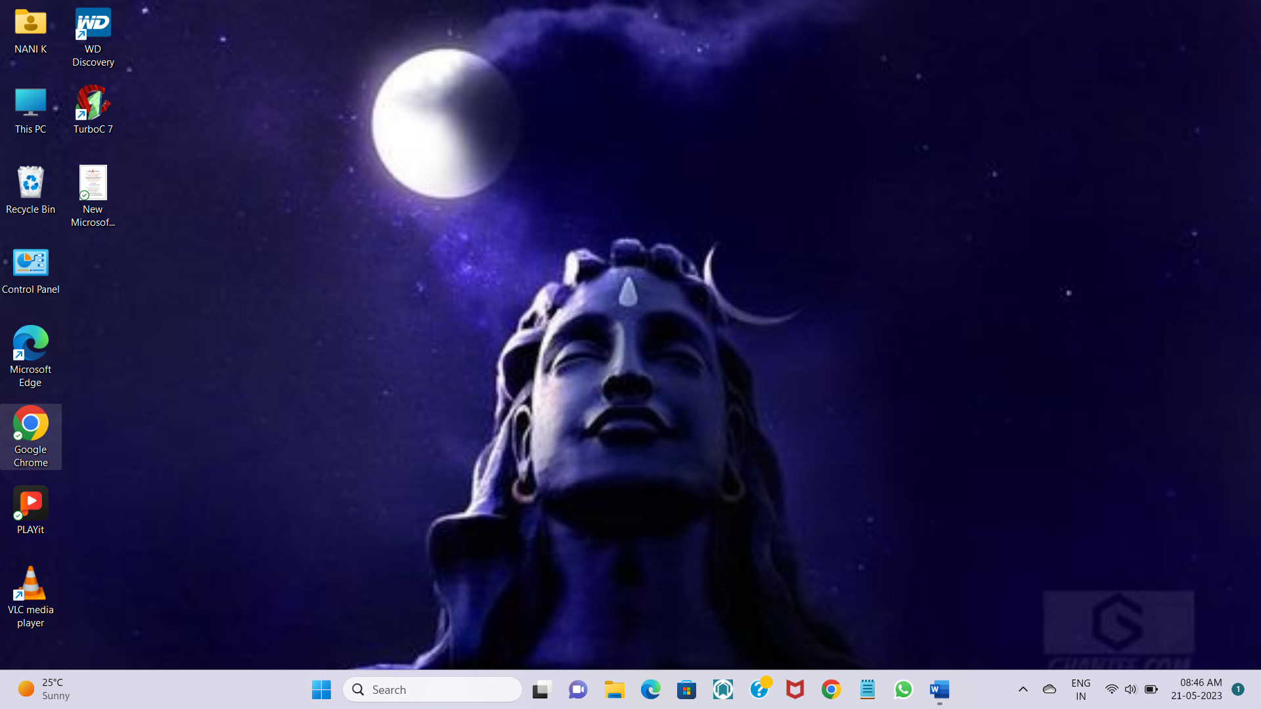Step 01:- Go to Chrome Browser
* 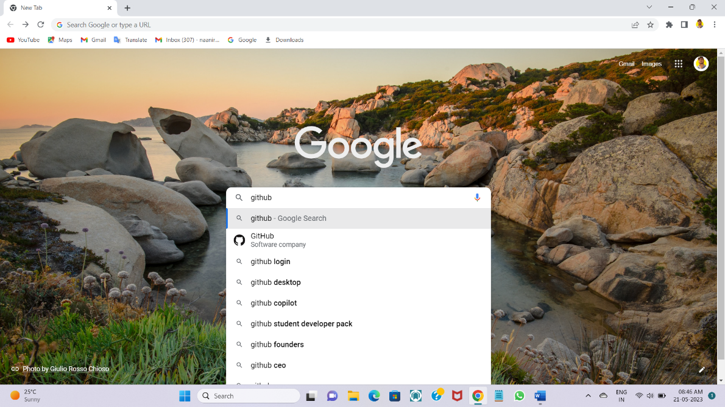Step 02:- Search GitHub in google and open it
* 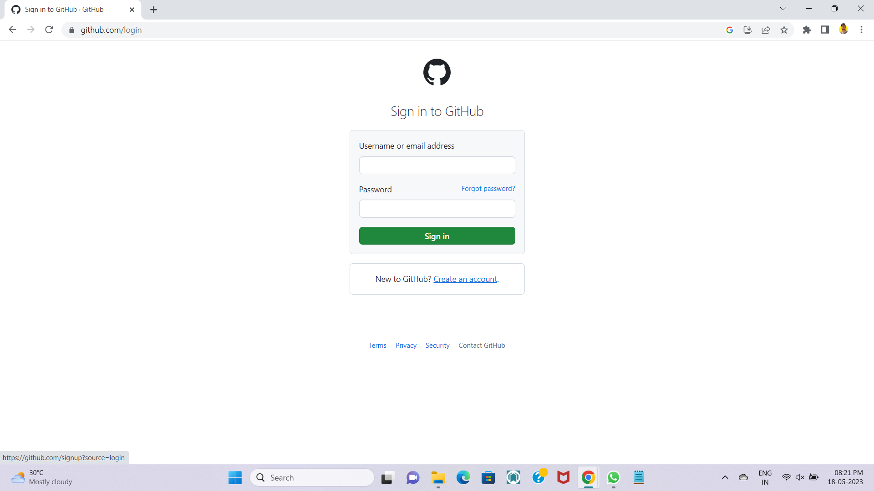Step 03:- Click on create an account

* Step 04:- Enter your E-mail Id and click on Continue.

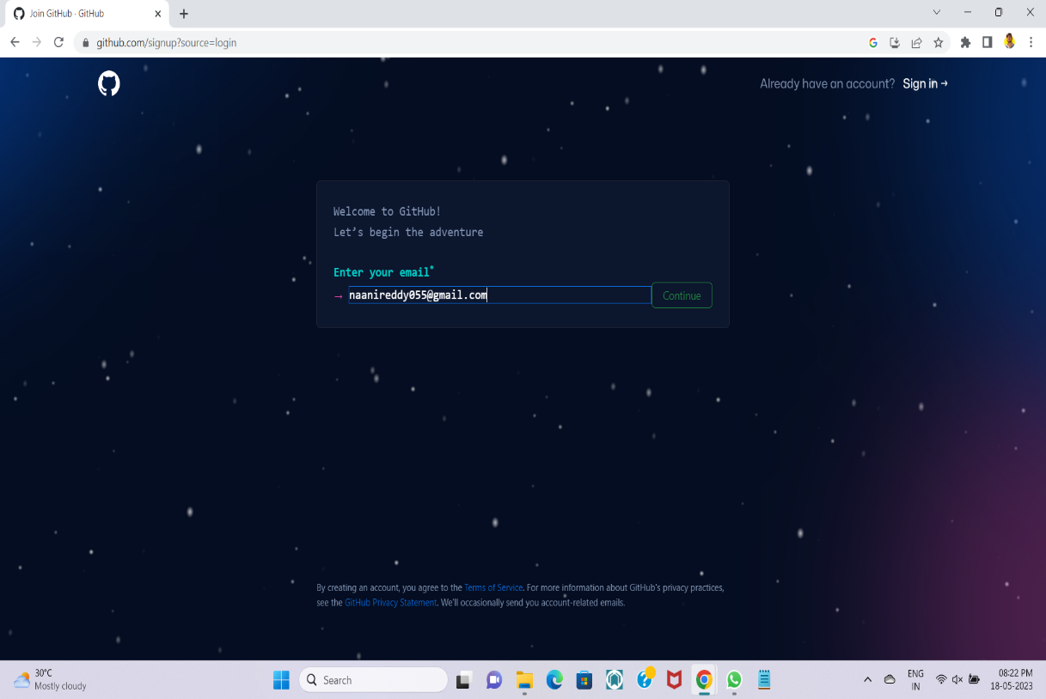

* Step 05:- Enter a strong password and clock on continue.

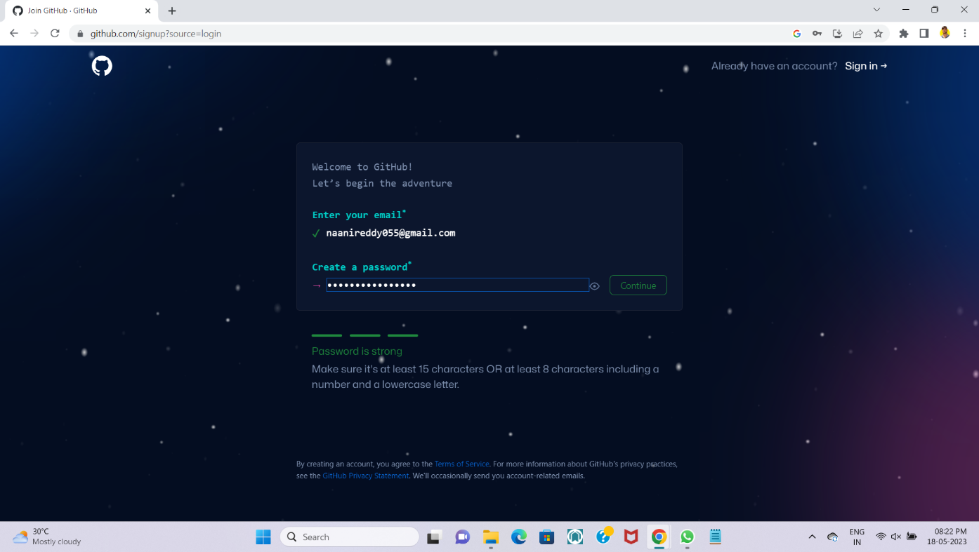

* Step 06:- Enter your user name and click on continue.

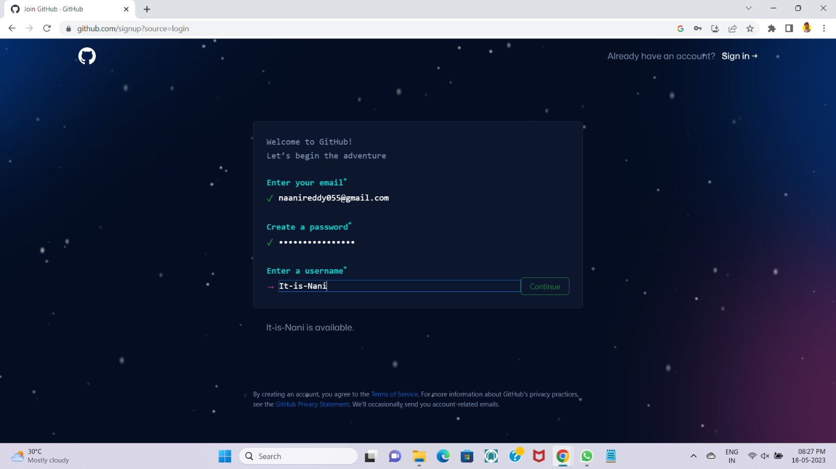

* Step 07:- Press Y to get notifications from GitHub.

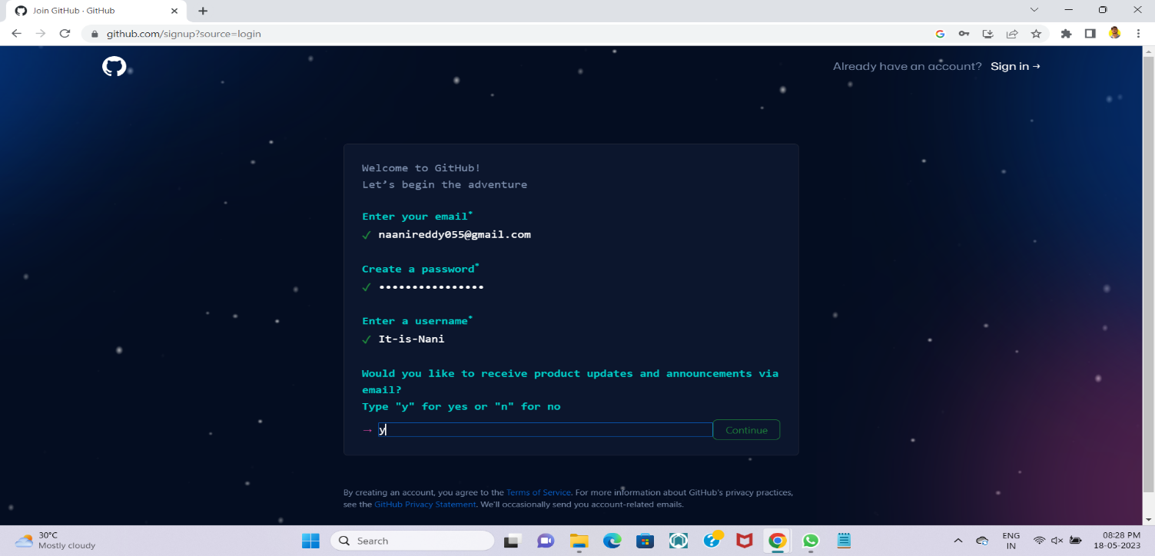

* Step 08:- Select same identical object to Verify your account.

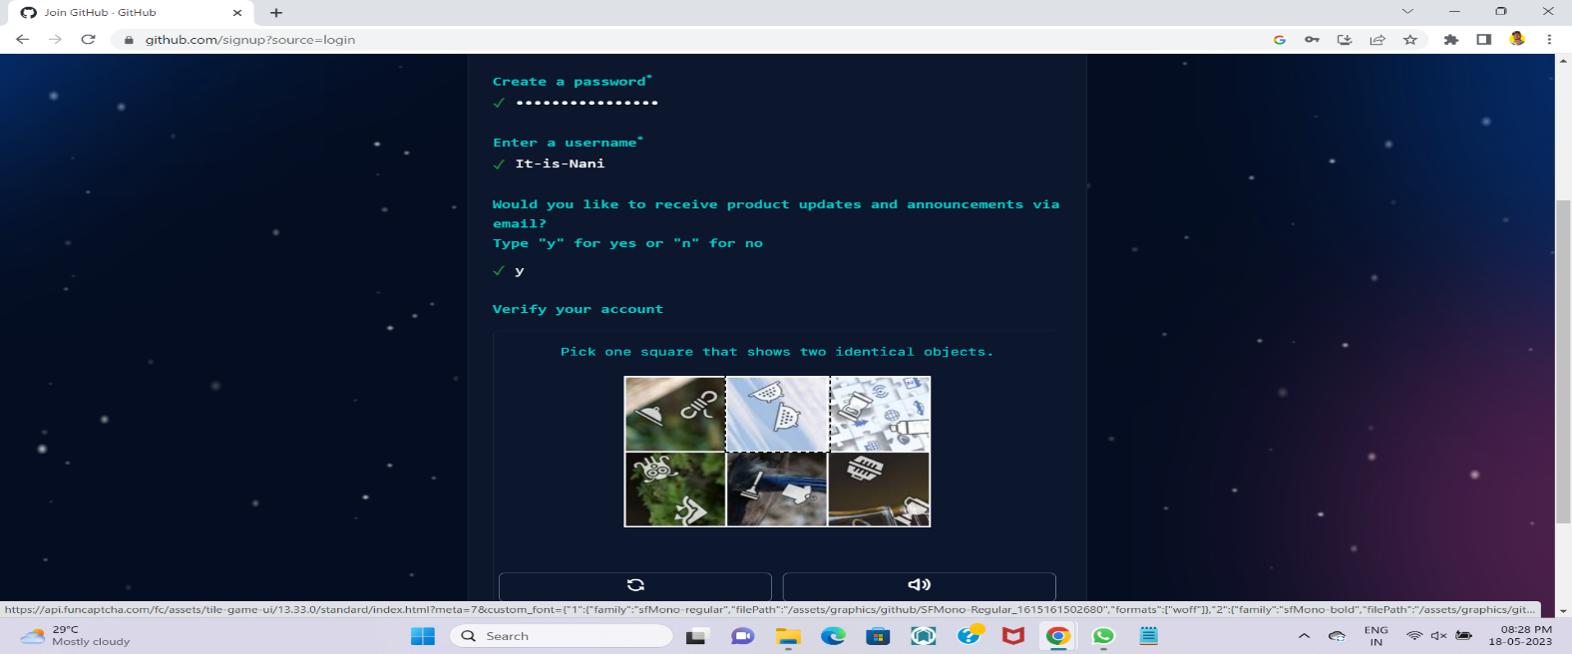

* Step 08:- Click on Create account and your account will be created.

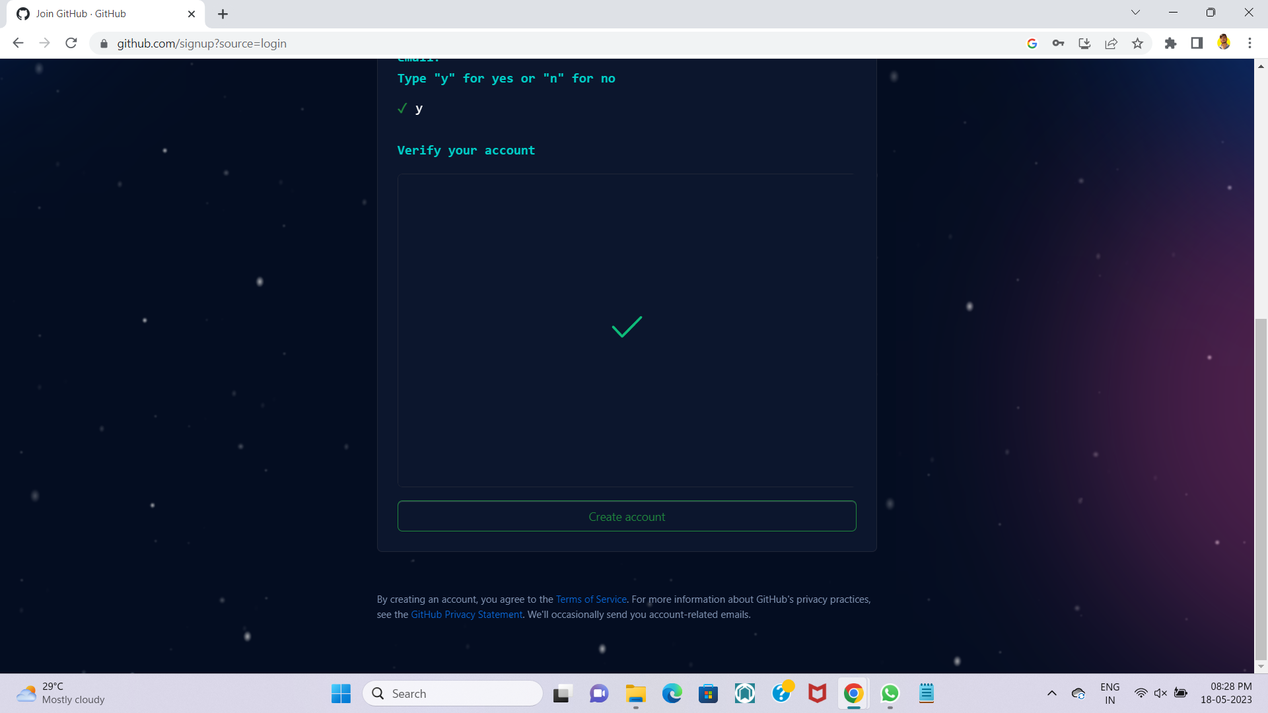

* Step 09:- OTP will come to your registered E-mail id to activate your account.

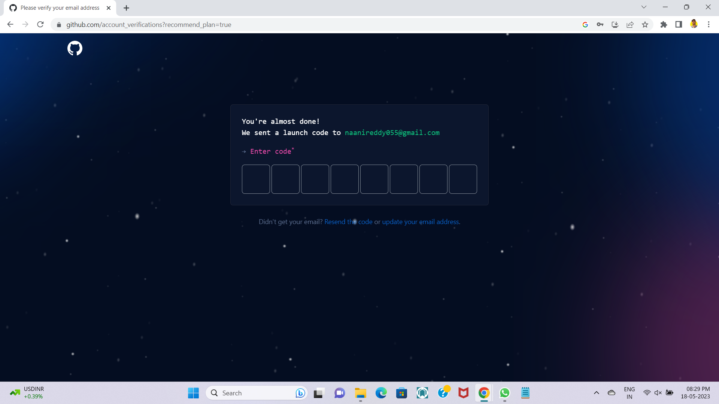

* Step 10:- Select your profession and your team members.

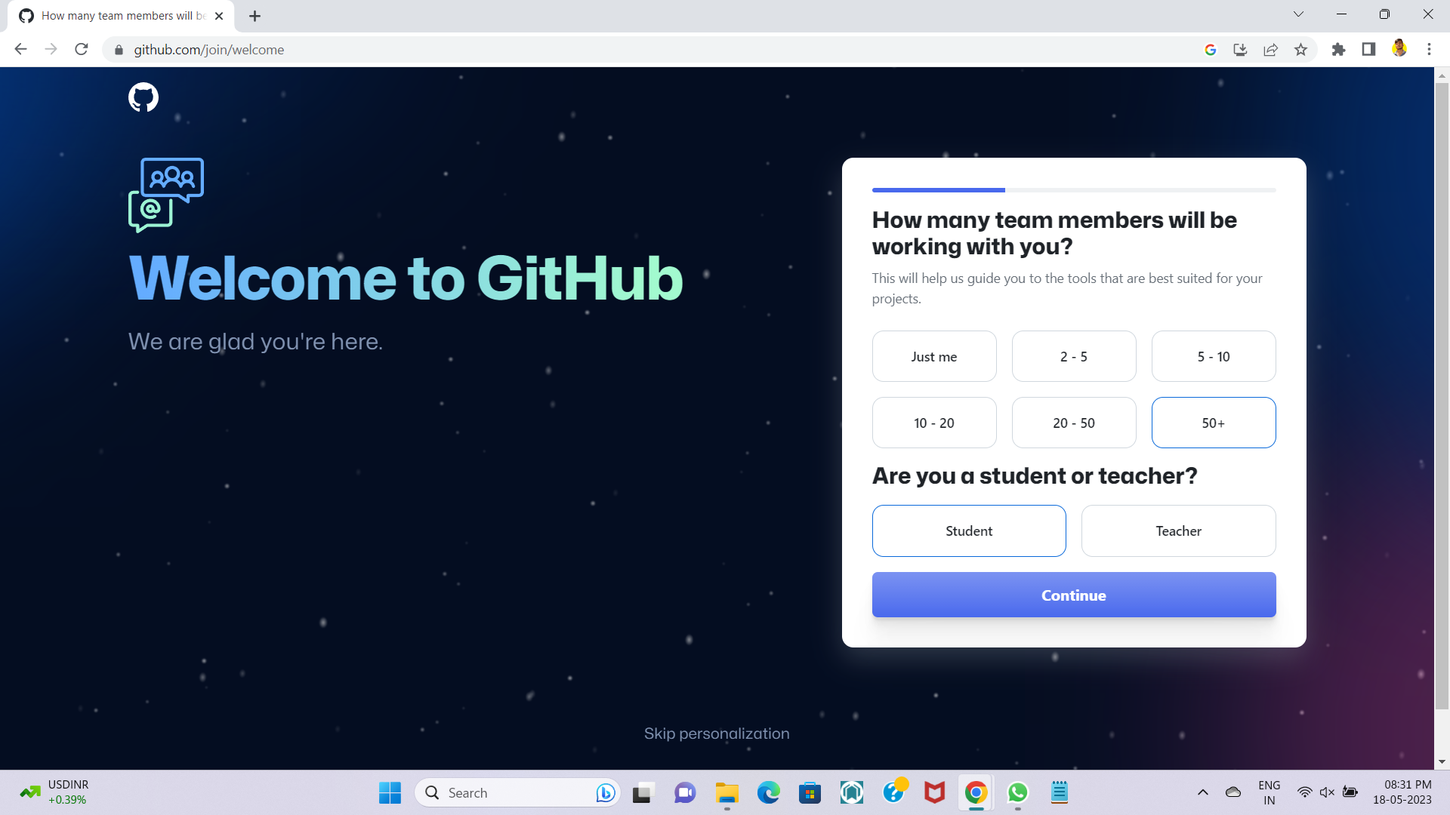

* Step 11:- Select all the fields and click on continue.

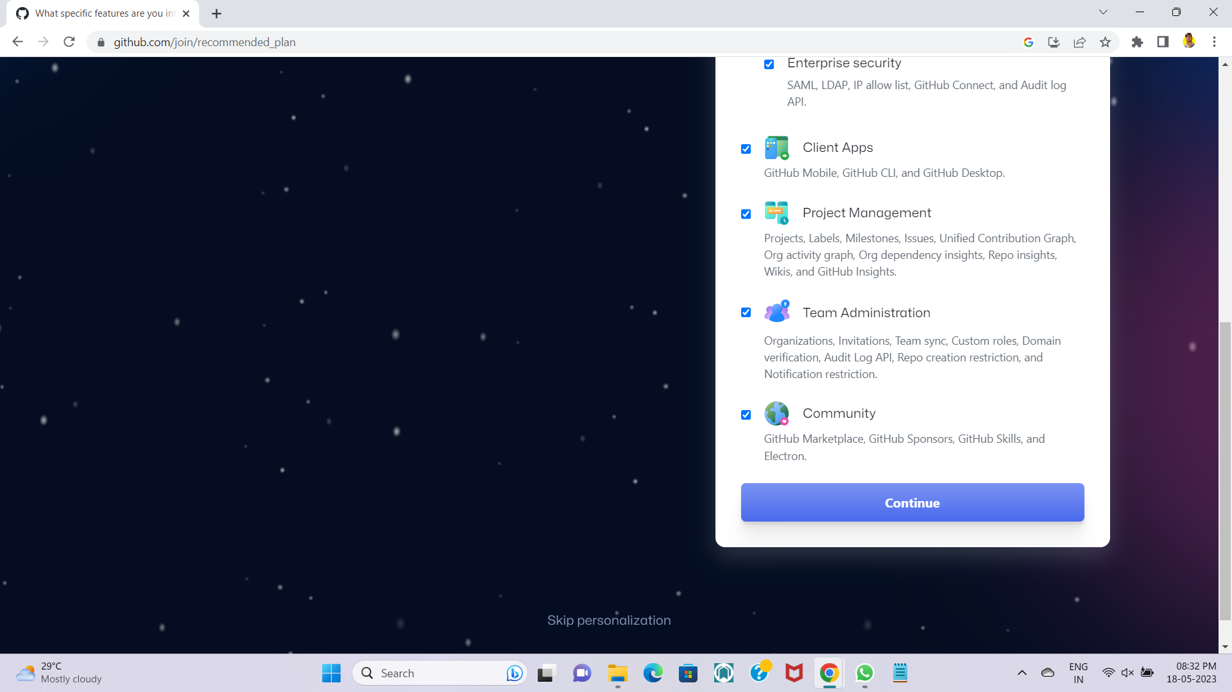

* Step 12:- Click on continue for free.

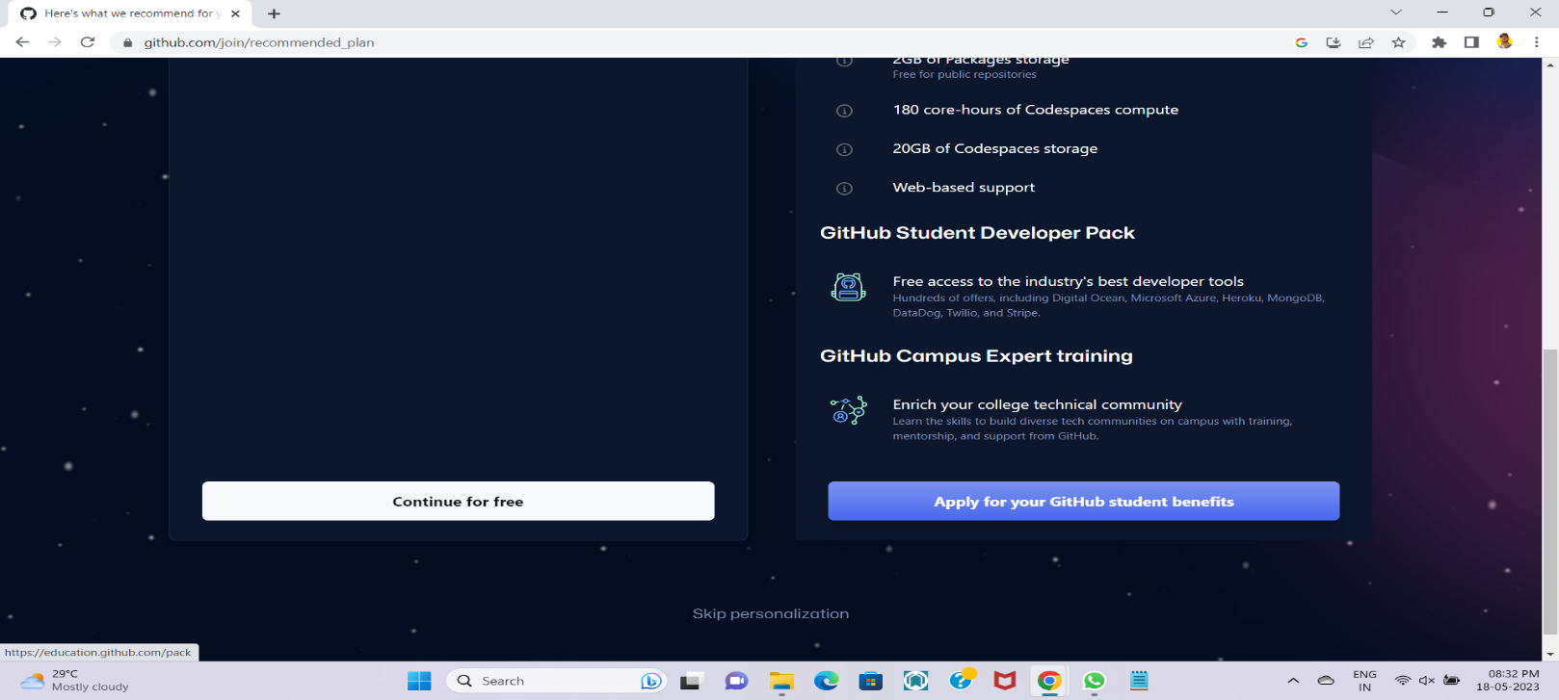

* Step 13:- Then your account will be created.

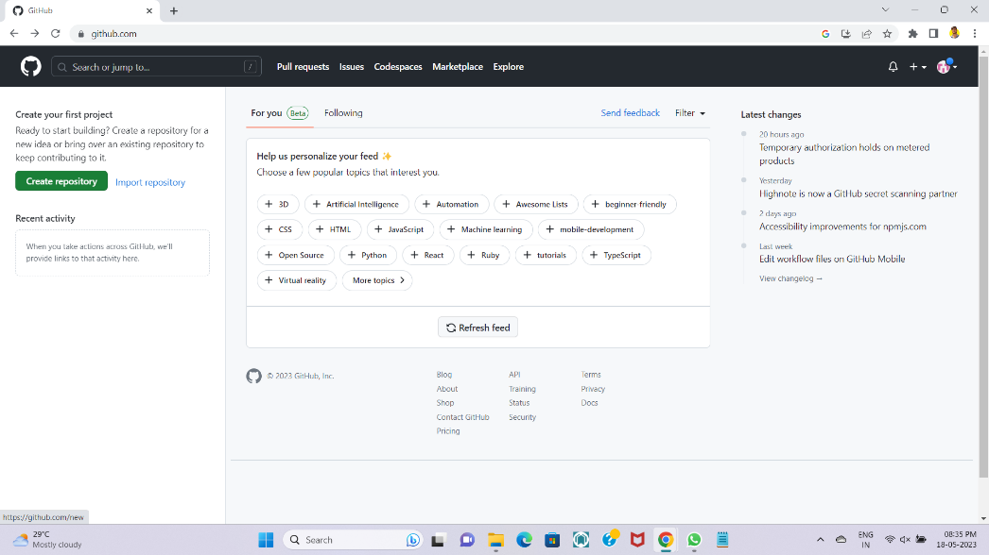

* 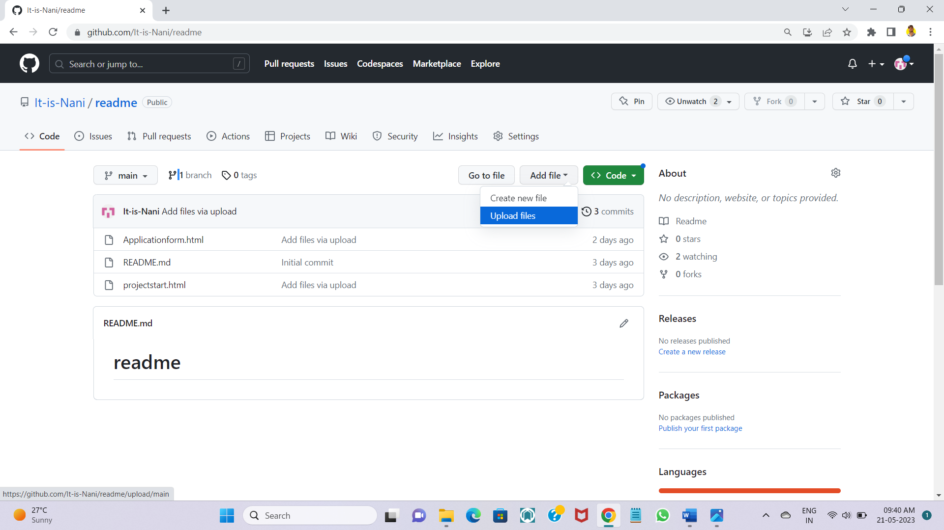Step 14:- Click on add file and select on upload files.

* Step 15:- Click on choose your files.

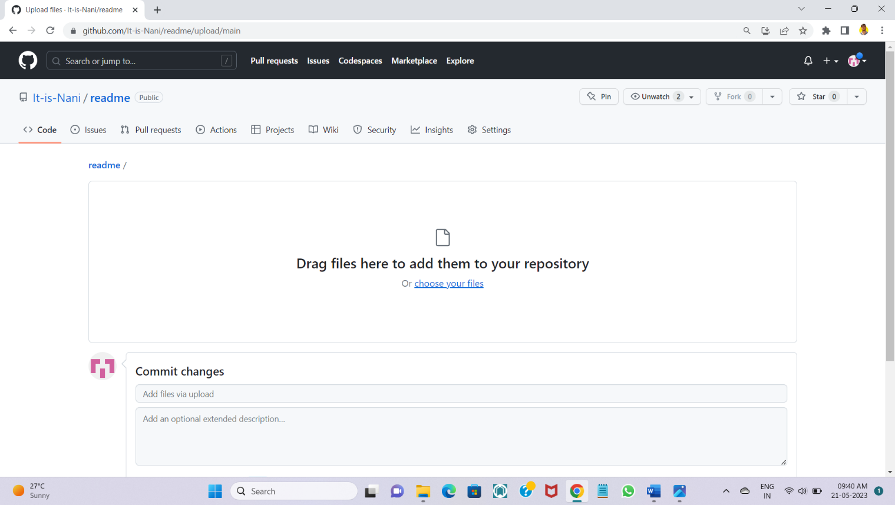

* 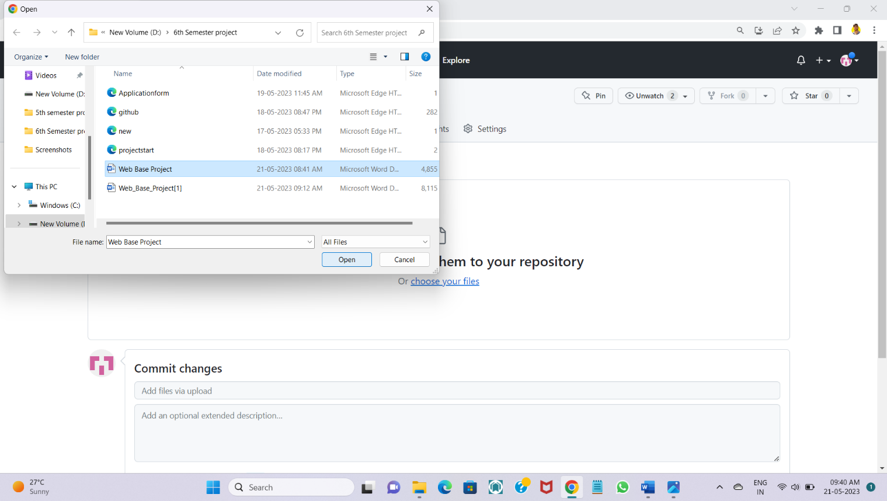Step 16:- Select the file which you need to share and click on open.

* 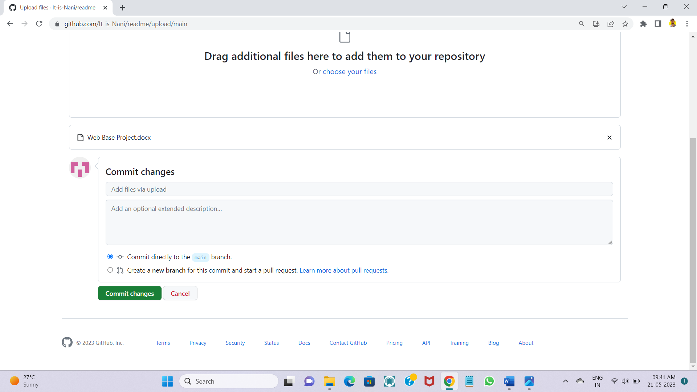Step 17:- Click on commit changes to save the file.

* Step 18:- Right click on Go to file and Copy link address to share the files to your team members.

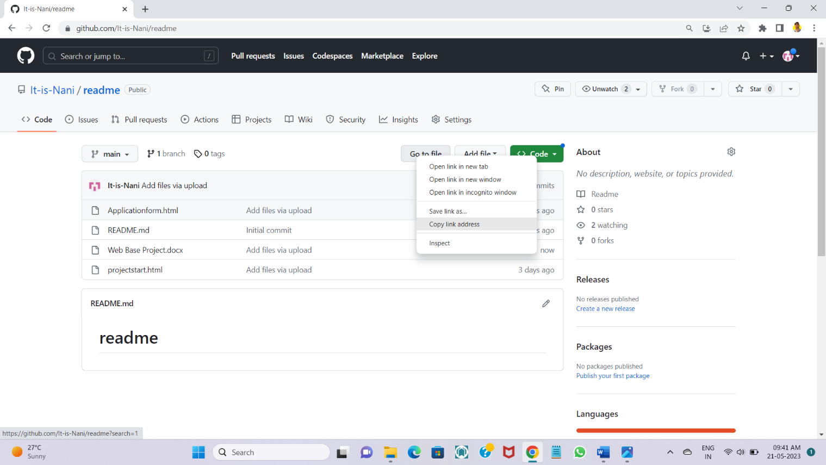

* 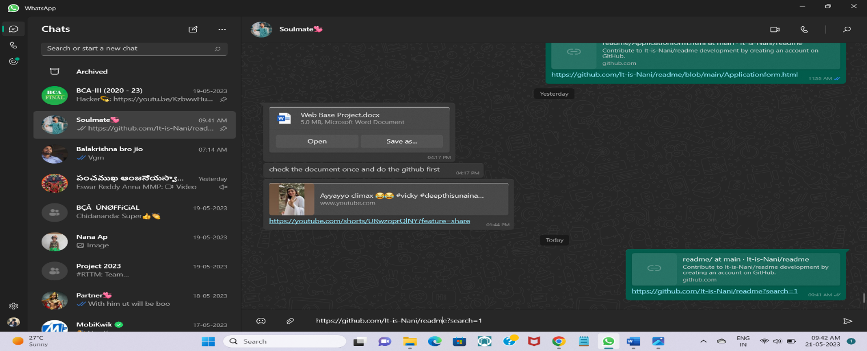Step 19:- To whom do you need send send to that person by pasting the link on the text box.